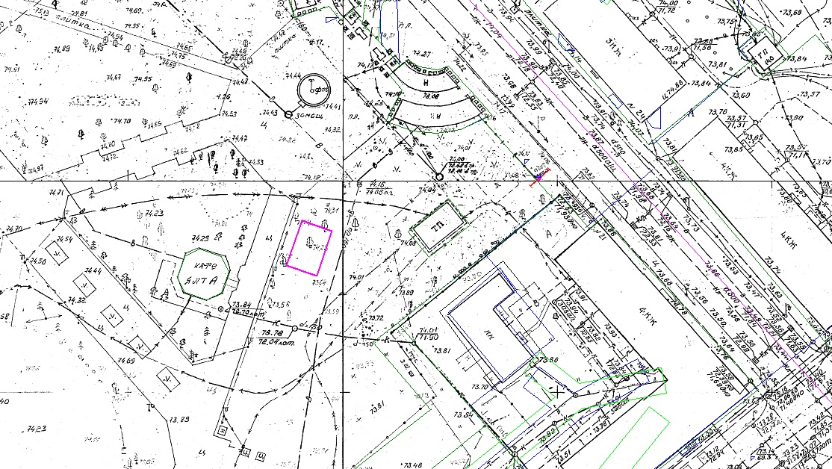

¹ X Y

1 -9,3206 240,4866

2 -19,9322 236,9226

3 -22,3486 244,0259

4 -11,8173 247,5048

1 -9,3206 240,4866